ELECTRICITY: TOO IMPORTANT TO LEAVE TO THE MARKET

A CONFERENCE ON RESTORING

JUST AND REASONABLE ELECTRICITY RATES

What we can do about electric industry restructuring

RestoreJustRates.org

Washington Court Hotel
525 New Jersey Ave., N.W.
Washington, D.C. 20001
202-628-2100
Fax 202-879-7918

EARLY REGISTRATION, 6:00 – 8:00 p.m., Friday, September 27, 2002

SATURDAY, SEPTEMBER 28, 2002

8:00 - 8:30 Coffee and registration

8:30 - 8:45 WELCOME: YOU CAN MAKE THE DIFFERENCE
Jerrold Oppenheim, Esq. for the Conference

8:45 - 9:15 KICK-OFF: WHAT WENT WRONG WITH RESTRUCTURING AND HOW WE CAN RESTORE JUST AND REASONABLE RATES
Commissioner Carl Wood, California Public Utilities Commission

9:15 – 10:45 THE MISTAKE OF DEREGULATION: IT CANNOT WORK
Richard Rosen, Executive Vice-President, Tellus Institute, Moderator and Speaker
Eugene Coyle, California-based consulting economist
Commissioner Nancy Brockway, New Hampshire Public Utilities Commission

10:45 – 11:00 Break

11:00 - 12:15 DEREGULATION FAILURES ACROSS THE WORLD
Robert Backus, Chairman, Campaign for Ratepayer Rights, Moderator
International failure: Steve Thomas, Senior Research Analyst, Public Service International Research Unit, University of Greenwich, London
US failures: Randy Chapman, Director, Texas Legal Services
Gerald Norlander, Director, Public Utility Law Project, New York
Charlie Harak, Attorney, National Consumer Law Center
Enron: Tyson Slocum, Research Director, Critical Mass Energy and Environment Program, Public Citizen

12:15 - 1:45 Lunch
Introduction of speaker, Theo MacGregor, MacGregor Energy Consultancy
Speaker: Robert Kuttner, Editor, The American Prospect and author, Everything For Sale

2:00 – 3:00 RESTORE JUST AND REASONABLE ELECTRICITY RATES
Re-regulate - Jerrold Oppenheim, Esq., Moderator and Speaker
Public power – Susan Kelly, Esq., Miller, Balis & O’Neill, Washington, D.C.
Don’t deregulate – Paul Cillo, former Majority Leader, Vermont House of Representatives
Democracy – Greg Palast, BBC correspondent and author, The Best Democracy Money Can Buy

3:15 – 5:30 Break-out sessions: DEVELOP STRATEGIES TO ACCOMPLISH THESE GOALS

1) How to re-regulate: where to begin; how to proceed; how to work within an existing framework (e.g., POLR and “Default Service”)
Commissioner Carl Wood, California Public Utilities Commission
Jerrold Oppenheim, Esq.
Theo MacGregor, MacGregor Energy Consultancy

2) Federal Policy, including RTOs and FERC: How to participate; how to organize
Mark Cooper, Research Director, Consumer Federation of America
John Howat, moderator, Senior Policy Analyst, National Consumer Law Center
Richard Rosen, Executive Vice-President, Tellus Institute

3) Strengthening environmental regulation
Robert Backus, Chairman, Campaign for Ratepayer Rights
Beth McConnell, State Director, PennPIRG
Wenonah Hauter, Director, Critical Mass Energy and Environment Program, Public Citizen

- Keeping unrestructured states strong
James Burg, Chairman, South Dakota Public Utilities Commission
Michael Dworkin, Chair, Vermont Public Service Board
Marilyn Showalter, Chairwoman, Washington (State) Utilities and Transportation Commission
John Stutz, moderator, Tellus Institute

- Protecting labor and consumers: service quality and other issues
Charlie Harak, Attorney for Utility Workers Union of America and National Consumer Law Center
Bernando Garcia, Region V Director, Utility Workers Union of America
Steve Thomas, Senior Research Analyst, Public Service International Research Unit, University of Greenwich, London

- Promoting public power
Dan Berman, Author, Who Owns the Sun?, Member, Davis (Calif.) Citizens Task Force on Energy Issues
Mark Loy, Vice-President and Chief Shop Steward, DLC 745, Local 1000, Service Employees International Union
Susan Kelly, Esq., Miller, Balis & O’Neill, Washington, D.C.
Cynthia Wooten-Cohen, Business-Financial Consultant, Founder, East Bay Power!, Berkeley, Calif.

4:00 – 4:15 Stretch break

5:15 - 5:30 Record strategies for Day 2 discussion (one for each break-out session)

Dinner on your own.

September 28, 8:30pm

Montpelier Room, Washington Court Hotel

(525 New Jersey Ave., NW) FREE ADMISSION

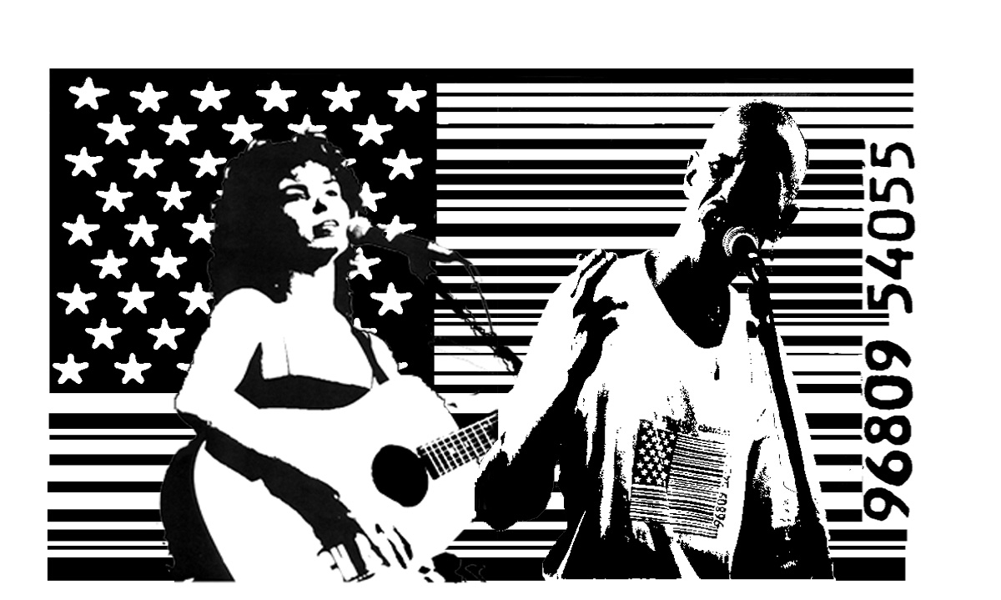
“The most creatively radical performers on the coffee house circuit”
– The Boston Herald
“She is the best labor singer in North America.” - U. Utah Phillips

“This man is dangerous.” – The Washington Post

SUNDAY, SEPTEMBER 29, 2002

8:00 – 8:30 Continental breakfast

8:30 – 9:00 THE NEED FOR ACTION – Loretta Lynch, President, California Public Utilities Commission, Introduced by Jerrold Oppenheim, Esq.

9:00 - 9:30 ORGANIZE FOR ACTION -- Keynote speaker: Don Wightman, President, Utility Workers Union of America, Introduced by Charlie Harak

9:30 – 10:45 Organize: Reports from Day 1 and discussion of strategies/tactics
Post write-ups from groups – David Hughes, Executive Director, Citizen Power, Moderator

10:45 – 11:00 Break

11:00 - 12:45 Action: Put strategies into operation – Charlie Harak, NCLC, Moderator
At FERC, other Federal fora, and RTOs – Recorder: Rich Rosen
In restructured states – Recorder: Jerrold Oppenheim
In not yet restructured or in repealed states – Recorder: Theo MacGregor

Summation of the conference
Identify resources;
What next?

SPONSORS:

American Public Power Association, Washington, D.C.
Campaign for Ratepayer Rights, Concord, N.H.
Citizen Power, Pittsburgh, Pa.
MacGregor Energy Consultancy, Gloucester, Mass.
National Consumer Law Center, Boston, Mass. and Washington D.C.
Law Office of Jerrold Oppenheim, Gloucester, Mass.
Tellus Institute, Boston, Mass.
Utility Workers Union of America, Washington, D.C.

