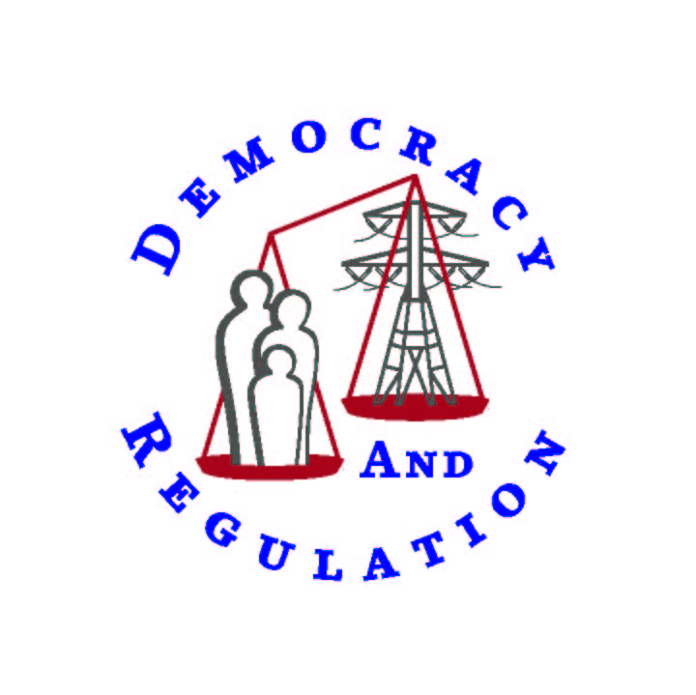

JERROLD OPPENHEIM
57 MIDDLE STREET
GLOUCESTER, MASSACHUSETTS 01930-5736 USA
+1 (978) 283-0897
Fax +1 (978) 283-0957
JerroldOpp@DemocracyAndRegulation.com
www.DemocracyAndRegulation.com

Regulating carbon progressively
January 18, 2008

It is important that any cap-and-trade system for carbon emissions be structured to have a progressive impact, i.e., have a lesser burden on (or even a net benefit to) low-income households than others. A basic assumption is that the proceeds of any such system are 100% returned to consumers. In summary, as the chart below illustrates, I would propose to structure the return to customers such that none is returned to the top quintile of earners, the middle 60% receive about what the system costs them so they break even, and the bottom quintile receives more than the system costs them.
This proposal would make the system net neutral for those in the middle because their incomes have been nearly stagnant for two decades and they are therefore neither economically nor politically ready for a sharp increase in taxation. Alternatively, the return could be structured to give this group a small net benefit. The relative economic difficulty of the bottom 80% is shown by these data compiled by the Center on Budget and Policy Priorities (CBPP) from US Census data:
Here is an illustrative example of how the distribution of costs and benefits might work:
Thus, depending on the price of carbon (this illustration approximates CBO’s mid-point), there may be sufficient revenue to return 3.5 times the cost of carbon to the poorest 20% while returning the cost of carbon to others (provided there is no benefit to the top 20%). Alternatively, this revenue would cover twice the cost to the poorest 20% and provide revenue for other purposes, such as research and development of sustainable technologies and mediation of worker dislocation. Many other alternatives of progressive distribution are possible.
The result of the first option – benefit to bottom 20%, no benefit to top 20%, break-even benefit to middle 60% -- is summarized in the table and chart below, compared with the results of no rebate (left block) or an equal per capita rebate (middle block). With no rebate whatsoever, the poorest (deciles 1-2) would receive the largest increase in energy costs, 10-11 percent, while the richest (deciles 9-10) the smallest, five-six percent. An equal per capita rebate would be mildly progressive – the richest would face an increase of two or three percent while the poorest would receive overall reductions of 24 percent (poorest) to ten percent (next-to-poorest); those in the middle would see relatively small changes, ranging from a one percent increase to a five percent reduction. Under the proposal of this paper, those in the middle would see no change at all, the richest would see the same increase (five or six percent) as if there were no rebate at all, and the lowest-income 20 percent would have energy expense reductions of 24 to 29 percent.
Distribution decisions are likely to be made on both Federal and State levels. This analysis of incomes is by quintile largely because much income data are reported that way. The analysis should be considered illustrative and could be refined to narrow the fraction of earners who pay the full costs of the system to, for example, 10% (with, say, the next 10% paying partial cost); and/or to narrow the fraction of earners who receive a net benefit to, say, a quarter, which would encompass those at or below 60% of median income (i.e., $28,814), a common definition of poverty. Note also that these national averages disguise wide differences in carbon use across regions and states. For example, emissions of CO₂ for Massachusetts residential electricity generation are about half the national average.
The mechanics for achieving this or similar structures could include a combination of the income tax system (including Earned Income Tax Credit and payroll tax credits), fuel assistance, energy efficiency, and/or other benefit programs. Middle income rebates can be administered through the income tax system. However, reaching the lower 40% will not be that easy. A number of methods have been suggested, none of them wholly suitable:
- Earned Income Tax Credit (EITC)
- Other Income Tax credits
- Payroll tax credits
- Fuel assistance (LIHEAP) supplement
- Energy efficiency program funding (through Weatherization Assistance Program or through utility-funded programs)
- Food stamps or other relatively popular low-income benefits
None of these programs fully identify or serve all those it is desirable to reach.
- Income tax credits, including the EITC, and payroll taxes do not reach non-working elderly, unemployed, and disabled people.
- The EITC also does not reach many working poor.
- Fuel assistance directly responds to increased energy prices but often reaches fewer than 25% of those who are income-eligible; energy efficiency programs reach even fewer. Of course, the low penetration of these programs – which are fully subscribed – is largely a function of grossly inadequate funding.
- Food stamps may be the most popular low-income benefit, but nevertheless reach fewer than half of those eligible.
The most effective approach is likely to be a combination of these programs, although coordinating such a set of programs could be a complex undertaking. For example, fuel assistance could be funded to (or beyond) its full $5 billion authorization, energy efficiency programs could be greatly expanded, and food stamps and EITC or payroll tax credits could be used to reach those not reached by fuel assistance or energy efficiency programs.
Fuel assistance is a desirable approach because it is an existing program, requiring no new administration, that was designed to directly respond to fuel price increases. Energy efficiency is a particularly desirable approach because the benefits it provides are long-term and greater than the amount invested.

The analysis is the same for a carbon tax, with the important exception that a carbon tax affects energy uses other than electricity, e.g., heating, transportation. It would be preferable to spread the burden of greenhouse gas mitigation across all major greenhouse gas emitters. The data here assume a 15% emissions reduction because most of the available analysis so assumes, based on current proposed legislation. Considerably greater reductions will ultimately be required, but costs can be scaled so this does not affect relative burdens and thus this analysis of progressivity.
Obviously, if a portion of the carbon credits created are given to emitters, that much less is available for low-income families. A Congressional Budget Office (CBO) analysis showed significantly regressive results from providing a portion of carbon credits to emitters or from returning the value of credits via reductions in payroll or corporate taxes. T. Dinan, “Trade-Offs in Allocating Allowances for CO2 Emissions” at 6-8 (CBO, April 25, 2007).
This analysis is preliminary and offers direction for more refined analysis.
J. Bernstein et al., “Pulling Apart: A State by State Analysis of Income Trends” (Jan. 2006). The income gap shown here has only worsened since. A. Aron-Dine, “New Data Show Income Concentration Jumped Again in 2005: Income Share of Top 1% at Highest Level Since 1929” (CBPP, Oct. 24, 2007).
Computed from J. K Boyce et al., “Cap and Rebate: How to Curb Global Warming while Protecting the Incomes of American Families” Table 7 (UMass-Amherst Political Economy Research Institute, Oct. 2007). Costs shown are costs of paying for carbon credits throughout the economy, on a per capita, per household, and per decile basis. Computations from the CBO quintile analysis yield very similar results. This does not represent Boyce’s recommendation, which is to achieve a measure of progressivity by an equal rebate to every person. His calculations show that his strategy would also have a progressive impact (though less so than this proposal), as the richest 40% would pay more in increased prices than they got back in rebates, while 60% would pay less (though not as much less on average as under this proposal). If 20% of carbon revenues were diverted to other purposes, then only the bottom 40% would pay less. At 12, 16.
This exercise assumed a carbon price of $200 per ton (about $55 per ton of CO₂) and estimated a reduction of 7% (at 11). The CBO study projected a total cost of $50-$300 billion (midpoint = $175B) and a reduction of 15% (at 2). Clearly, there is enormous uncertainty about what carbon credits will cost and how much emissions reduction will be achieved at any given cost of carbon. In any event, in the long run, all these estimates are likely to be too low to achieve the needed carbon reductions.
I.e., this shows the gross impact of the carbon credit charges with no revenues from carbon credit sales returned to consumers, e.g., credits are entirely allocated to emitters, revenues are allocated to research and development, tax cuts, and/or deficit reduction.
There should be no concern that this will cause usage increases, since this population struggles to pay all its bills and consumes energy, and other goods and services, with extreme penuriousness.
60% of the 2005-2006 US median household income; http://www.census.gov/hhes/www/income/income06/statemhi2.html.
See J. Oppenheim & T. MacGregor, “The Economics of Poverty” at 1 (Entergy Corp. 2006), www.democracyandregulation.com/detail.cfm?artid=99&row=0. By comparison, the maximum income subject to the Earned Income Tax Credit in 2007 is in the $40,000 range, depending on family size. R. Greenstein et al., “Designing Climate-Change Legislation That Shields Low-income Households From Increased Poverty And Hardship” at 13 (CBPP, Oct. 25, 2007).
New England electricity emissions are 0.98 pounds per kWh, compared to a national average of 1.34. www.eia.doe.gov/pub/oiaf/1605/cdrom/pdf/e-supdoc.pdf (1998-2000 data). Massachusetts residential electricity usage averages 7367 kWh, compared to a national average of 14,787 kWh. www.eia.doe.gov/cneaf/electricity/epa/customers_state.xls (2006 customer counts), www.eia.doe.gov/cneaf/electricity/epa/sales_state.xls (2006 sales data).
For example, nearly half of those in the bottom 20% do not pay payroll taxes. R. Greenstein et al., “Designing Climate-Change Legislation That Shields Low-income Households From Increased Poverty And Hardship” at 8 (CBPP, Oct. 25, 2007).
In many cases, income-eligible households are students or families who pay their energy costs as part of their rent (the latter about 20% according to DOE’s Residential Energy Consumption Survey (RECS), see R. Greenstein et al., “Designing Climate-Change Legislation That Shields Low-income Households From Increased Poverty And Hardship” at 5 (CBPP, Oct. 25, 2007)). Estimates of penetration nationwide are as low as 1/6. R. Greenstein et al., “Designing Climate-Change Legislation That Shields Low-income Households From Increased Poverty And Hardship” at 5, n.8 (CBPP, Oct. 25, 2007). However, this varies widely by state and probably underestimates penetration by not adequately accounting for nominally eligible students and residents of subsidized and institutional housing. Note also that home energy costs addressed by fuel assistance only account for about 45% of low-income energy expenditures and do not include such other energy costs as those for gasoline (25%) and other goods and services. R. Greenstein et al., “Designing Climate-Change Legislation That Shields Low-income Households From Increased Poverty And Hardship” at 4 (CBPP, Oct. 25, 2007).
Since 2002, appropriations have varied between $1.7 and $1.98 billion (except $2.48 billion in 2006). LIHEAP Clearinghouse, “LIHEAP Funding History 1977-2007,” http://liheap.ncat.org/Funding/lhhist.htm. Contingency funding enacted for FY 2008 could bring the year’s total to $2.57 billion. www.neada.org/appropriations/2007-12-20.htm.
CBPP estimates that about three-quarters of those in the bottom 20% receive food stamps, the EITC, or Medicare prescription drug benefits. R. Greenstein et al., “Designing Climate-Change Legislation That Shields Low-income Households From Increased Poverty And Hardship” at 11 (CBPP, Oct. 25, 2007).
This is true from both participant and societal perspectives. See our studies of low-income efficiency benefit:cost ratios for Entergy, Massachusetts utilities and low-income network, and DC District Department of the Environment – Energy Office at www.DemocracyAndRegulation.com (cost-effectiveness issue).

