The State of Retail Competition:

A Failed Experiment, or an Essential Reform Just Beginning?

Harvard Electricity Policy Group
Twenty-Ninth Plenary Session
Cambridge, Mass.
September 27, 2002

Jerrold Oppenheim, Esq.
57 Middle Street
Gloucester, Mass.
+1-978-283-0897
Fax +1-978-283-0957
JerroldOpp@DemocracyAndRegulation.com
www. DemocracyAndRegulation.com

PRICE

RELIABILITY
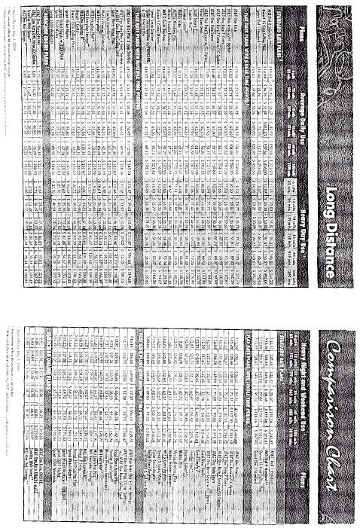

STATE | COMPETITOR SHARE OF CUSTOMERS
 | RES. |  | NON-RES.
DC | 8% |  | 19%
ILLINOIS | -- |  | 4%
MAINE | <1% |  | <10%
MARYLAND | 3% |  | 6%
MASS. | 2% |  | 10%
NEW JERSEY | 0.2% |  | 0.1%
NEW YORK | 5% |  | 7%
OHIO | 20% |  | 6%
PENNA. | 6% |  | 3%
TEXAS | 4% |  | 12%
Sources: US DOE EIA, September 2002 (data from March,
June, July); US DOE EIA, Jan. 2002 (some 2000 customer
data, which overstates share); Texas Legal Services (Tx
PUC data)

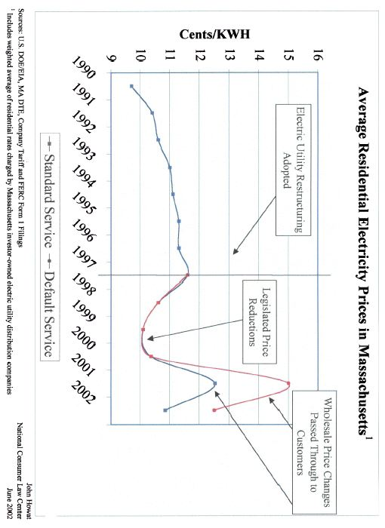
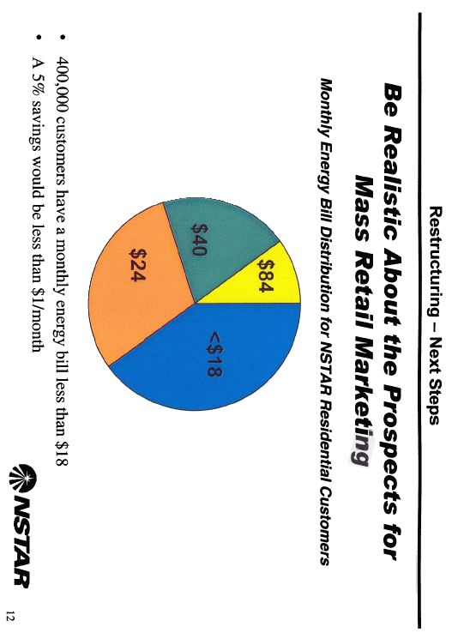
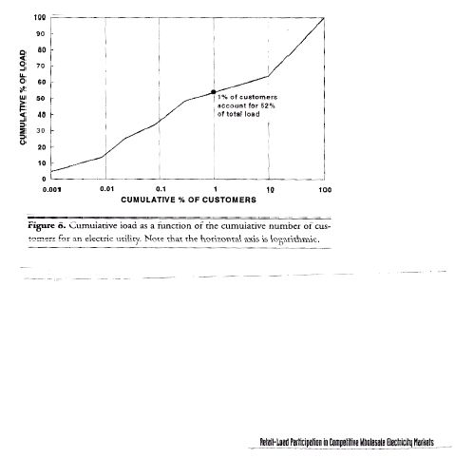
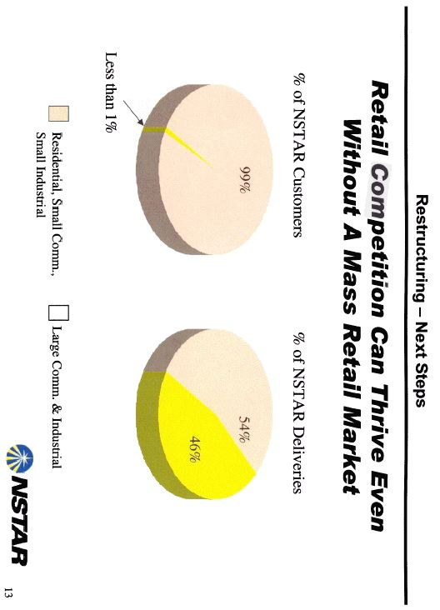

ELECTRICITY IS UNIQUE

- ESSENTIAL

- NO SUBSTITUTE

- INELASTIC

- NO STORAGE

- BARRIERS TO ENTRY

Decreased value - last 52 weeks
AES | 95%
Calpine | 91%
Dynegy | 97%
Mirant | 92%
Reliant Resources | 80%
Xcel [NRG] | 78%
Citigroup | 45%
JP Morgan Chase | 49%
Source: Wall St. Journal (Aug. 6, 2002)

RECOMMENDATIONS

- PORTFOLIO MANAGEMENT

- SUPPLY MANAGEMENT

- NO SLAMMING

- “OREGON MODEL”

- LOW-INCOME SUPPORTS

…it must be emphasized that the creation of competition is beneficial only if it produces savings for ratepayers. The payment of higher prices to create a competitive market, just for the sake of having a competitive market, is economic logic turned upside down. The Commission rejects it.
…If a competitive residential market is going to develop, it should be through a natural development, not through the imposition of artificially inflated prices designed to benefit the marketers and suppliers to the detriment of residential ratepayers.

Narragansett Electric Co., 216 PUR4th 232, 246 (RI PUC, Feb. 15, 2002) (citation to quoted 1998 orders omitted, emphasis in original)

