STATE OF CONNECTICUT

GENERAL ASSEMBLY

ENERGY AND TECHNOLOGY COMMITTEE

TESTIMONY OF JERROLD OPPENHEIM

CONCERNING

S.B. 733 (LCO No. 3210)

AND

H.B. 6030 (LCO No. 3200)

January Session, 2003

THE STANDARD OFFER FOR ELECTRICITY IN CONNECTICUT

Jerrold Oppenheim, Esq.
57 Middle Street
Gloucester, Massachusetts 01930
978-283-0897
Fax 978-283-0957
JerroldOpp@DemocracyAndRegulation.com

February 19, 2003
STATE OF CONNECTICUT
GENERAL ASSEMBLY
ENERGY AND TECHNOLOGY COMMITTEE

TESTIMONY OF JERROLD OPPENHEIM

CONCERNING S.B. 733 (LCO No. 3210)
AND H.B. 6030 (LCO No. 3200)
January Session, 2003

THE STANDARD OFFER FOR ELECTRICITY IN CONNECTICUT

My name is Jerrold Oppenheim. I have been a public interest lawyer and advocate for residential utility consumers for more than 30 years, including 11 years on behalf of four Attorneys General in New York State and Massachusetts. Some of my most recent work includes contributions to nation-leading protections for consumers and low-income families in the Connecticut, Massachusetts, and Texas electricity restructuring statutes, and contributions to precedent-setting regulatory decisions protecting consumers and low-income families in Illinois, Massachusetts, New Hampshire, New York, Texas, and Utah. I have also published widely on public utility and consumer law topics, including recent papers on the development of residential electricity rates in restructured states for the Electricity Journal, on electric utility service quality measurement for the National Association of Regulatory Utility Commissioners (NARUC), on recommended electricity labeling disclosures for the National Council on Competition and the Electric Industry, on low-income discount and efficiency programs for the Entergy Corp., and on US utility regulation for the National Consumer Law Center (NCLC), the UN’s International Labor Office (ILO), the European Federation of Public Service Unions (EPSU), The Bergen Conference (Norway), and the European Trade Union Institute (ETUI). My book on US utility regulation, Democracy and Regulation, was published this month by Pluto Press (London).

The purpose of my testimony today is to recommend that the General Assembly take further steps to protect the residential electricity consumers of Connecticut from the wild swings of deregulated electricity prices. The General Assembly took a path-breaking step in originally enacting a Standard Offer for a fixed four-year term. This fixed term allowed Connecticut’s distribution utilities to purchase power at a stable price. With competition for residential customers nonexistent in Connecticut, or elsewhere, the Standard Offer should be extended indefinitely, again with conditions that make it possible to provide reasonable and stable electricity prices to Connecticut families. The principle strategies I recommend to achieve this objective are (1) requiring the purchase of wholesale electricity for a mix of contract durations (portfolio management) in order to minimize the impact of any one price change, and (2) arranging for sufficient electricity generating plant capacity such that shortages neither drive prices to unreasonable levels nor threaten service reliability (brownouts and blackouts).

1. Unregulated electricity prices are extremely volatile

As the US Department of Energy, Energy Information Administration (EIA), has shown, electricity prices are by far the most volatile among energy prices – which are themselves among the most volatile of commodity prices:

The experience of New England since most electricity generation prices were deregulated confirms DOE’s findings. It does not take a trained eye to determine when, on the chart that follows, electricity was deregulated:

Not surprisingly, as the Commonwealth of Massachusetts discovered, tying retail electricity rates to volatile wholesale rates results in volatile retail rates. (For the most part, Massachusetts limits distribution utility wholesale purchases to six month or one year contracts.)
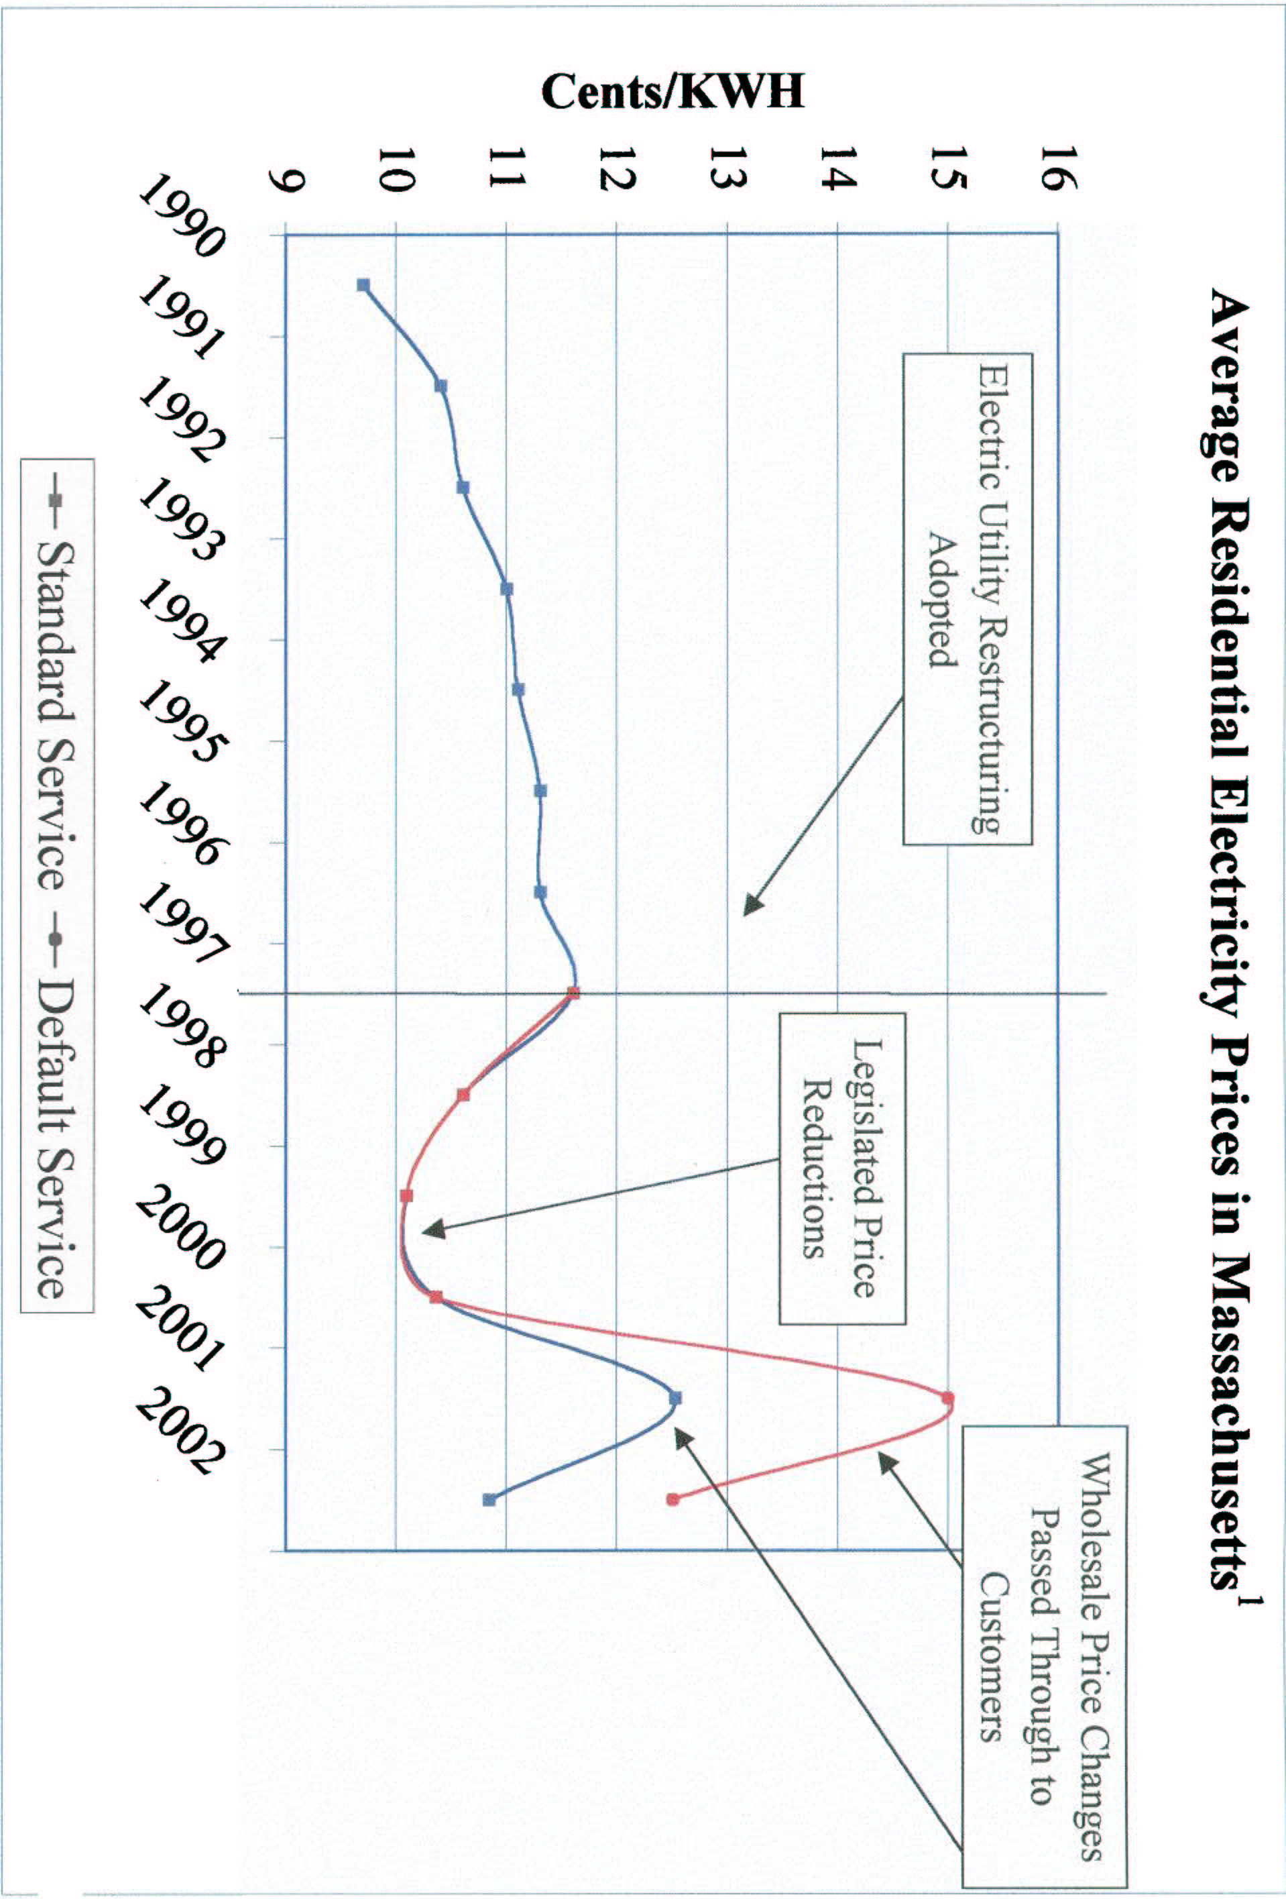
Wholesale New England prices varied by about 300 percent. Massachusetts retail rates, based on the wholesale roller coaster but including non-generation elements, have varied by about 50 percent. And it could have been much worse.

New England has enjoyed a relative surplus of generation, which tends to depress prices. By way of contrast, the California debacle, rolling blackouts included, was caused in part by generation shortages. Extended price spikes that reached 1000 percent have resulted in permanent retail price increases of 40 percent.

As others will describe in greater detail today, such price volatility for an essential service is extremely difficult for ordinary families to budget for. It is impossible for low-income families to budget for and forces a literal choice between lights and food.

Price volatility is an inherent feature of the boom-and-bust cycle dictated by the economics of the capital-intensive nature of the electricity generation industry. The “price signal” (high prices) caused by electricity shortages provides an incentive for investment in new generation. However, that very investment causes a surplus – such as we now enjoy in New England – which causes prices to fall, following the elementary law of supply and demand from Economics 101. Such price drops cause a cessation of investment and even cancellation of existing construction plans. (Across the country, projects totaling more than 75,000 mW have been deferred or cancelled.) Ultimately, demand grows (or wholesalers withhold, mothball, or retire generation) until another shortage is created, and the cycle repeats. This is projected to occur in New England 2005 or 2006.

The resulting price volatility is difficult not only for consumers. The current cycle has had a devastating impact on the wholesale generation industry itself, as well as on its financiers, wiping out billions of dollars in equity:

Consumers don’t avoid these losses, as they are passed along in the form of higher costs of capital and reduced reliability, i.e., the reduced ability of the industry to raise capital to meet demand for electricity.

As luck would have it for Connecticut, we are currently in the surplus phase of the cycle (the bust from the point of view of generators and their financiers) – a relatively good time to buy relatively long-term contracts. If the system is left unchanged, as surplus turns into shortage, prices will rise.

2. Competition will not protect residential consumers

There are two dueling theories about competition for residential electricity customers – markets are either the most efficient means of assuring customers the lowest prices, or markets for residential electricity are not economically feasible because transaction costs exceed the efficiencies available in the marketplace. While the economists are dueling, the real world offers more than five years of empirical evidence: in essence, competitive markets for residential electricity have all the substance of Harvey The Invisible Rabbit. As of March 31, 2003. the last competitor for residential customers will leave Connecticut.

Here are the facts:

Plainly, competitive residential electricity markets are a fiction and not an economic policy.

3. Portfolio management is a tested means of protecting residential consumers from price volatility.

Just as dollar-cost-averaging and diversification can protect investors from the vicissitudes of the stock market, a diversified portfolio of resources can protect residential consumers from price volatility. Thus a managed portfolio might draw from fuels with uncorrelated prices and supplies, such as natural gas, hydro, and biomass. Similarly, a managed portfolio will draw from both demand- and supply-side resources, efficiency improvements as well as generation. And a well-managed portfolio will sample prices across a range of time periods through a mix of short-, medium-, and long-term contracts. While long-term contracts may carry the risk of a price that is fixed over time, they also benefit from the reduced risk borne by the generator that it will have a market for its output.

Portfolio management is needed as an antidote to market power. Market power is most easily exercised in short-term markets where bidding strategies and capacity withholding can be profitable to suppliers. Portfolio management can reduce the risk of market power by relying more on long and medium-term contracts and other proven risk management tools and less on spot markets. The long-term market is much less susceptible to these practices. The long-term market also benefits from the price–reducing effects of new entrants, new technologies, and other efficiency gains. Thus, in addition to reducing consumers’ exposure to unwanted price volatility, another key role of portfolio management is to reduce consumers’ exposure to market power–ridden, short-term markets. The use of portfolio management may be the greatest leverage state regulators have to influence the actual operations of wholesale markets.

An important corollary to the principle of portfolio management is that the load being served in part with long-term resources must itself be reasonably stable. For risk to be reduced in this strategy, a resource mix that includes long-term supply must be balanced by a load mix that includes long-term customers. The evidence is that residential customers are more likely to be such a stable class of customers and they should therefore be maintained as a separate class of customers so they reap the benefit of their stability.

Connecticut and Maine have demonstrated the perhaps obvious fact that a multi-year contract can provide stable prices for a number of years. In Maine, the state took over the function of generation procurement, insisting on multi-year bids in order to achieve price stability. After initially receiving no suitable bids, the state has currently locked in three-year prices for its three largest investor-owned utilities. In the case of the largest utility, Central Maine Power, the rate is lower than before restructuring despite New England wholesale price volatility. Other examples include the United Kingdom, where long-term purchase contracts are used to mitigate price volatility, and New York, where Consolidated Edison is offering a ten-year purchase contract in order to attract generation investment in New York City.

A New York State regulatory policy requires gas utilities to also purchase a mix of contract durations in order to contain price volatility:

Local [gas] distribution companies [LDCs] have many ways to meet their loads; they should consider all available options … [which] may include short and longer term fixed price purchases, spot acquisitions, the use of financial hedges … While we are not directing any particular mix of portfolio options, volatility of customer bills is one of the criteria, along with other factors such as cost and reliability, that LDCs should consider … Any utility without a diversified pricing strategy will have to meet a heavy burden to demonstrate that its approach is reasonable.

Similar actions to stabilize prices have been ordered or authorized in, for example, Arkansas, Kentucky, Georgia, Colorado, Iowa, Oklahoma, Kansas, Missouri, Mississippi, and California. While most recent regulatory attention has focused on spiking gas prices, the same principles apply to the potential for spiking electricity prices.

4. Establishing a builder of last resort is necessary to assure reliability of the electricity system and will also help protect residential customers from unreasonable and volatile prices.

While portfolio management will make retail prices more stable, it will not necessarily make prices reasonable or supply more reliable. Consolidated Edison’s offer to purchase 500 mW for ten years is an example of the need for a builder-of-last-resort that arises during the boom-and-bust cycle described above. As described earlier, it is in generators’ interest to allow surplus capacity (reserves) to dwindle to the point where shortages allow price spikes. Reliability, on the other hand, requires sufficient surplus capacity such that shortages are not threatened. Thus providing reliability reserves also provides discipline to market prices.

Generators demonstrated in California that keeping the lights on is not a market objective. California had no back-up system to provide generation and the lights went out. In New York two years ago, when shortages (and higher than usual prices) loomed in New York City and Long Island, the New York Power Authority used its authority to build enough small, but unpopular, plants to meet the emergency. Now Con Ed is attempting to fulfill this function with an RFP for 500 mW. Ultimately, it may have to be the job of the regulated distribution utility to assure that there is enough power to keep the lights on.

Conclusion

I will conclude with advice from the utilities commission to our immediate East:

…it must be emphasized that the creation of competition is beneficial only if it produces savings for ratepayers. The payment of higher prices to create a competitive market, just for the sake of having a competitive market, is economic logic turned upside down. The Commission rejects it.
…If a competitive residential market is going to develop, it should be through a natural development, not through the imposition of artificially inflated prices designed to benefit the marketers and suppliers to the detriment of residential ratepayers.

To protect residential electricity consumers, I urge you to adopt the strategy of portfolio management and assure that there is a builder-of-last resort to prevent blackouts.

US DOE EIA, “Derivatives and Risk Management in Energy Industries” at p. x (Oct. 2002) (data from CFTC, except CPI Retail Inflation estimate added by author of this testimony).
John Howat, National Consumer Law Center (June 2002), from US DOE EIA, Mass. Department of Telecommunications and Energy, Company tariff and FERC Form 1 filings. (N. 1 to chart: Includes weighted average of residential rates charged by Mass. investor-owned electric utility distribution companies.
E.g., P. Rigby (director of Utilities, Energy and Project Finance, Standard & Poor’s), “Is time running out for U.S. energy merchant companies? Part II: Recovery prospects in default,” Plat’s Energy Business & Technology 19, 22 (January/February 2003).
The shortages were apparently based on withholding of generation by wholesalers. E.g., Manipulation of Electric and Natural Gas Prices, Order Approving Stipulation and Consent Agreement in Docket No. PA02-001 (FERC, Jan. 31, 2003) (approving settlement with Reliant for, among other things, payment of $13.8 million, which “reflects the worst case scenario of the effect of Reliant’s withholding on the California market,” and citing such telephone transcripts as “we decided that the prices were too low on the daily market so we shut down …”); N. R. Brooks, “State Finds More ‘Suspicious’ Plant Outages Los Angeles Times, p. C2 (Jan. 31, 2003).
See J. Bhattacharya at al., “Heat or Eat? Cold Weather Shocks and Nutrition in Poor American Families” (National Bureau of Economic Research, June 2002) (poor families reduce food expenditures during unusually cold weather by about the same amount as they increase fuel expenditures).
Fitch Ratings, “Outlook 2003: U.S. Power & Gas/Wholesale still weak, but contagion slowing” (Dec. 17, 2002) (e.g., “unprecedented turmoil. … Ongoing wholesale price pressure due to capacity overbuild.”); P. Rigby (director of Utilities, Energy and Project Finance, Standard & Poor’s), “Is time running out for U.S. energy merchant companies? Part II: Recovery prospects in default,” Plat’s Energy Business & Technology 19, 22 (January/February 2003); R. Smith, “Surplus of Electricity Supplies May Persist at Least Until 2005,” Wall St. Journal at p. A3 (Feb. 12, 2003).
See Fitch Ratings, “Outlook 2003: U.S. Power & Gas/Wholesale still weak, but contagion slowing” (Dec. 17, 2002).
“Green Mountain Energy pulls plug in Connecticut,” Fairfield County Business Journal (Jan. 27, 2003).
US DOE EIA, September 2002 (data from March, June, July); US DOE EIA, Jan. 2002 (some 2000 customer, data, which overstates share); Texas Legal Services (Tx PUC data). Note that Ohio residential share is virtually entirely at the operating utilities of one holding company and is the result of a rate agreement. To these residential results can be added Virginia (0%) and California (2% at maximum). See P. Cross, “State PUCs Show Split Personality/While electric restructuring pauses, telecom pushes forward,” Public Utilities fortnightly at p. 10 (Feb. 15, 2003).
C. Harrington et al. (Regulatory Assistance Project),, “Portfolio Management: Protecting Customers in an Electric Market That Isn't Working Very Well” (The Energy Foundation and The Hewlett Foundation, July 2002)
K. Silverstein, “Maine Uses Innovative Approaches to Deregulation” (UtiliPoint, Feb. 17, 2003).
Personal communications, Consumer Advocate Stephen Ward (Oct. 29, 2001), consumer consultant Barbara Alexander (Oct. 30, 2001).
Ofgem, “Electricity supply competition” (Dec. 16, 2002). This is not to suggest approval of the substantial disadvantages of the UK system.
K. Johnson, “A Chief Goal of Deregulation, Real Choice, Remains Elusive,” New York Times (Feb. 9, 2003).
Statement of Policy Concerning Gas Purchasing Practices at 4-5, Case 97-G-0600 (April 28, 1998).
Arkansas Gas Utilities, 210 PUR4th 325 (Ark. PSC 2001).
Western Kentucky Gas Co., 210 PUR4th 331 (Ky. PSC 2001).
Savannah Electric Power Co., 210 PUR4th 335 (Ga. PSC 2001).
Dec. No. C01-207 in Colo. PUC Docket No. OIR-0835 (March 27, 2001).
Docket No. RMU-00-6 (Iowa Utils. Bd. June 21, 2000).
R. Linden, “Gas Price Prudence: From Hedge-and-Hope to Best Practice,” Public Utilities Fortnightly at 34 (Oct. 1, 2001).
See note Error: Reference source not found, above.
Narragansett Electric Co., 216 PUR4th 232, 246 (RI PUC, Feb. 15, 2002) (citation to quoted 1998 orders omitted, emphasis in original).

