COMMONWEALTH OF MASSACHUSETTS DEPARTMENT OF TELEOCMMUNICATIONS AND ENERGY

Provision of )
) D.T.E. 02-40
Default Service )

INITIAL COMMENTS OF MASSACHUSETTS COMMUNITY ACTION PROGRAM DIRECTORS ASSOCIATION, INC. (MASSCAP) AND MASSACHUSETTS ENERGY DIRECTORS ASSOCIATION

Summary

Around all the talk about competition in electricity markets, one fact stands out: price matters to everyone.

Of all consumer product prices, electricity prices are now the most volatile. Efforts to encourage competition have not addressed this problem in the residential sector – indeed, competition has failed to reach the vast majority of retail residential electricity customers anywhere in the country.

Deregulation of wholesale electricity generation prices has dramatically increased electricity price volatility. Volatile prices for essential services are difficult for residential customers and especially harsh for low-income families, already beset with energy payment burdens that are proportionately triple those of the average Massachusetts family. Sixty percent of Massachusetts family incomes have fallen or not changed through the apparently booming 1990s. The softening economy of the years since makes matters worse.

The remedy for unaffordable price volatility is straightforward. The remedy is not raising prices further, or taking the highest bid offered for retail service, in order to encourage “competition.” Residential consumers need managed electricity portfolios to provide them with reasonable, stable prices.

Indeed, there is broad consensus, or near consensus, around the Commonwealth on three important points:
- Residential retail electricity competition is not working;
- Electricity prices to residential customers should be reasonable and stable, and
- A rolling average portfolio is an appropriate remedy, with a mix of contracts for residential customers of up to two years under current conditions.

Description of the Commenters

These Initial Comments are filed, pursuant to the Department’s Order Opening Investigation (June 21, 2002), on behalf of the low-income weatherization and fuel assistance network (described in G.L. c. 25, sec. 19), the Massachusetts Community Action Program Directors Association Inc. (MASSCAP), and the Massachusetts Energy Directors Association, including their member agencies.

G.L. c. 25, sec. 19 (St. 1997, c. 164, sec. 37) provides that “The low-income residential demand-side management and education programs shall be implemented through the low-income weatherization and fuel assistance program network …” MASSCAP is the organization of community action programs that make up most of the low-income weatherization and fuel assistance program network. Members of MASSCAP implement electric utilities’ low-income DSM programs, including education; they also process applications for LIHEAP and other assistance for Company customers. The Massachusetts Energy Directors Association (MEDA) is a voluntary association of directors of such energy programs at community action programs and the other agencies that make up the low-income weatherization and fuel assistance program network.

Members of MASSCAP, and agencies led by members of MEDA, counsel customers of the Commonwealth’s electric utilities about rates and payment options, and arrange rate payment assistance (including LIHEAP and other forms of assistance). Many Massachusetts consumers, especially the low-income customers served by members of MASSCAP and MEDA agencies, are currently having an especially difficult time paying their bills due to the significant increases in the past two years in the price, and the price volatility, of both natural gas and electricity commodities.

These Commenters are thus substantially affected by the level and volatility of electricity prices because (a) their clients (or clients of their members and agencies) are more likely to require assistance as rates and volatility rise, (b) the efficiency, weatherization, education, counseling and payment assistance services they (or their members and agencies) offer are less likely to result in affordable utility bills for their clients as rates and volatility rise, (c) they (or their members and agencies) will be increasingly called upon to secure other means of assistance with utility bills as rates and volatility rise, (d) they (or their members and agencies) will be increasingly called upon to assist clients who have had utility service terminated for non-payment, and (e) they will be called upon by their members and agencies to assist them in helping members’ and agencies’ clients as rates and volatility rise. Commenters also represent the interest of their (or their members’ and agencies’) clients in reasonable and stable rates that they can afford to manage and pay; clients are substantially affected by rates that they cannot afford to pay because they are unreasonably high or volatile.

The status of competition

As the chart below displays, there has been extremely little retail competition in the residential sector in the four years the market has been open in Massacusetts. Note that, despite the expansion of the last few months, the top of the scale is only 2.5 per cent.

This experience is universal. Even the “poster-child” of competition, Pennsylvania, where competitors applaud the rules, no more than 35 percent of residential customers in any service territory receive competitive service. Indeed, in most territories, the fraction – as here – is under one percent.

One marketer describes New York State as ideal due to its lack of utility price caps. The maximum residential penetration there is 21 percent of customers, with other territories ranging from 11.9 percent down to 0.04 percent.

Even in the rare case where 30 percent penetration is achieved by a residential retail competition program, 70 percent of the population is not reached. Clearly, at least for the foreseeable future, there must be an alternative in place by which residential customers can receive vital electricity service on reasonable terms. The experience to date is that, for the vast majority of residential customers, taking Default Service does not even constitute a choice to not shop.

In fact, the Oregon Legislature concluded that it would take so long for residential retail competition to develop that it was not worth waiting. Instead, it provided a permanent regulated rate for residential customers.

Proposals to force competition

Some suggest forcing residential competition by various means, as if competition were the objective of restructuring rather than reasonable prices. For example, the suggestion has been made that residential retail customers be arbitrarily assigned to competitors. Depending on the proposal, this assignment would either be real or “virtual”; in the latter case, the marketer would essentially get marketing rights to a group of customers.

Obviously, acquisition of customers in this way is valuable to the acquirer. Two data points provide possible measures of that value:
- Centrica recently paid American Electric Power about $166 per customer in Texas; and
- Southern Co. recently paid Enron affiliate New Power $131 for each gas customer in Georgia.
Thus a customer assignment program might be worth about $330 million statewide, not counting any additional value to such divestiture from the point of view of a divesting utility.

All proposals for involuntary assignment of customers to retailers should be analyzed against at least these two legal and policy templates:
- Is it slamming?
- As a transfer of a portion of the current franchise responsibility to procure power,
  - is the public interest met?
  - do monetary benefits go to customers?

If competitors cannot or will not offer reasonably-priced electricity to small customers, steps should be taken to protect the interests of these consumers in a stable and reasonably-priced supply of electricity. Raising the price of default service, or arbitrarily assigning customers to competitors in order to enhance their business, is a tax to subsidize unsuccessful businesses.

Proposals to separate Provider of Last Resort (POLR) service from basic residential service

Others suggest variations on the Texas model of providing a separate POLR service for customers who cannot obtain basic service or who are “between competitive suppliers.” The experience in Texas has been a consumer disaster with prices as high as 40 percent above the basic utility-affiliate price.

In essence, the Texas model provides a dumping ground for customers not desired by the standard supplier (a utility affiliate), usually due to poor credit. These customers, who are required to pay stiff deposits and thus represent little credit risk to the POLR supplier, become long-term customers because they have no alternative. However, prices are set (it is claimed) to reflect only the high perceived supply risk imposed by the other customers in the pool, who are by definition short-term customers in the process of leaving one competitive retailer for another.

The Texas model is unjust and unreasonable in Texas and should not be considered elsewhere.

Price volatility

The total weighted average price for Massachusetts residential electricity, particularly for Default Service, has risen sharply since 1997 and been extremely volatile. Starting at about 11.5 cents per kWh, the weighted average price dropped to 10 cents, skyrocketed 50 percent to 15 cents, and has recently dropped back to about 12.5 cents. This roller coaster is the total price; since distribution rates have been stable, the competitive energy rate has been much more volatile.

Thus the electricity price volatility experienced by Massachusetts consumers is a direct result of the policy of passing through the wholesale price volatility shown in the chart below without managing it.

New England’s wholesale electricity price volatility is perfectly ordinary. For example, in peak periods over the years 1998-2001, the ratio of maximum price to average price has been:
- 1610 percent to 3269 percent at PJM;
- 353 percent to 4368 percent in the Cinergy Market; and
- 331 percent to 3060 percent at ECAR.
Even averaging peak period prices across an entire year reveals significant volatility. In that four-year period, the variation (highest price divided by lowest) has been:
- 140% at PJM;
- 150% at Cinergy; and
- 120% at ECAR.
In other words, over just four years, the highest average peak price for a year has been as much as 50 percent higher than the lowest such price in a year.

Not surprisingly, US Energy Information Administration data show that electricity prices are the most volatile of energy prices, which are themselves the most volatile of commodity prices.

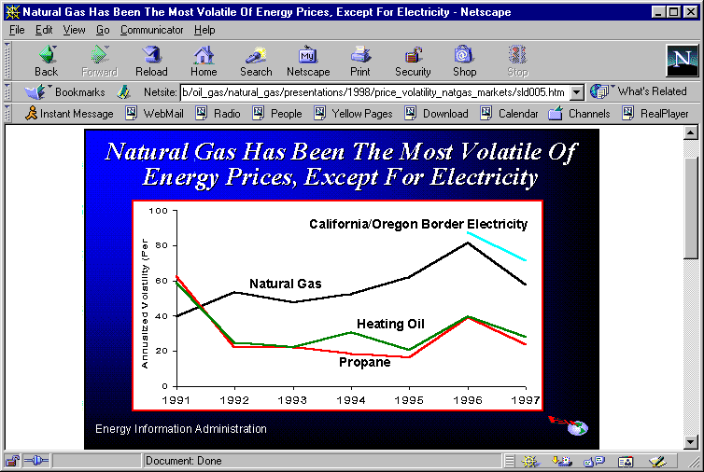

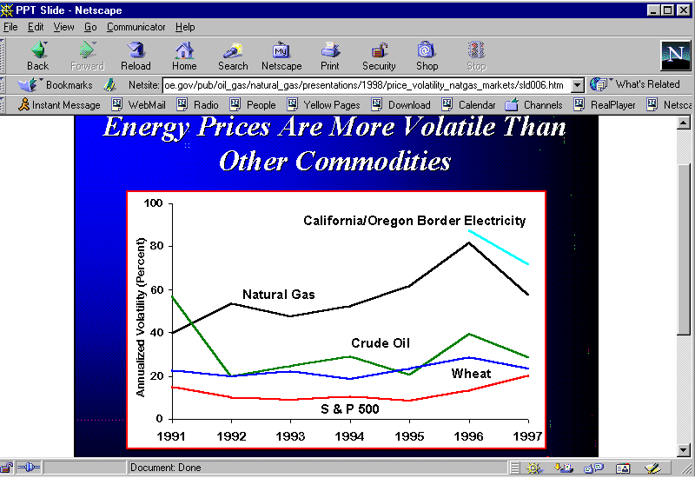

Financial instability

Some have cheered the combination of divestiture of utility generation and deregulation of wholesale generation prices as a way of shifting the financial risks of unwise decisionmaking away from ratepayers. However, unwise decisionmaking has continued, albeit by different entities. Ratepayers remain at risk.

Multi-hundred-million-dollar losses, accounting scandals, and a collapse in trading has poised more than one wholesale generation supplier at the edge of bankruptcy and even punished their financiers. Share values have evaporated:

Decreased value - last 52 weeks
AES | 95%
Calpine | 91%
Dynegy | 97%
Mirant | 92%
Reliant Resources | 80%
Xcel [NRG] | 78%
Citigroup | 45%
JP Morgan Chase | 49%
Source: Wall St. Journal (Aug. 6, 2002)

Standard & Poor’s, for example, has downgraded about 90 of its ratings in the power sector, some to below-investment grade (“junk”) status. As a result, “capital markets are now virtually closed to the country’s most capital intensive industry.” From consumers’ point of view, the risks thus remain of (1) unreliable provision of power due to inadequate capacity caused by unavailable financing or (2) higher prices due to high costs of capital. Retail regulators should redeem the original promise to shield ratepayers from the risks of unwise decisions in the generation sector. At the least, this means not raising regulated retail prices in order to support deregulated entities that are in financial trouble.

The harshness of electricity price volatility

The constantly moving target of electricity bills is especially difficult for the bottom 40 percent of Massachusetts families, whose inflation-adjusted incomes fell during the boom of the 1990s -- which also drove up housing prices in many parts of the Commonwealth much faster than the rate of inflation. For the middle 40 percent of Massachusetts families, incomes were flat (up zero to four percent). And now the post-September 11 unemployment rate is the highest in seven years. Only the top fifth of Massachusetts families was better off through the 1990s – incomes up 14 percent. (Within this group, the top five percent did even better, incomes up 18 percent.)

We are used to thinking of Massachusetts as a relatively generous home for low-income families. And in countless ways it is. But it is striking that Massachusetts incomes were falling through the 1990s even as all income sectors nationally experienced increases (though the income gap widened nationally as it did here).

On average in the Commonwealth, the energy burden of low-income families is triple that of median income families.

To imagine what life is like for the typical low-income family, imagine a household in the upper five percent bracket paying $24,000 per year or more to heat and light their home.

Principles

For residential customers, electricity restructuring has been characterized by sharp price volatility and very little competition. The following principles should be drawn from this experience and applied to Default Service:

- Prices should be reasonable, i.e., as low as possible consistent with costs;
- Prices should be stable;
- Low-income protections should be maintained and enhanced to make electricity affordable;
- Consumer protections should be maintained, no matter the source of supply;
- The system of supply should be robust, i.e., adaptable for conditions of competition or lack thereof.

As the Rhode Island commission recently held:

…it must be emphasized that the creation of competition is beneficial only if it produces savings for ratepayers. The payment of higher prices to create a competitive market, just for the sake of having a competitive market, is economic logic turned upside down. The Commission rejects it.
…If a competitive residential market is going to develop, it should be through a natural development, not through the imposition of artificially inflated prices designed to benefit the marketers and suppliers to the detriment of residential ratepayers.

Proposal

The most probable means of balancing the goals of reasonable and stable prices is to manage the procurement portfolio with that objective. To do so, we propose the following:
- each utility should dollar-cost average a series of purchases;
- purchases should vary in duration, the way a bond portfolio might be laddered;
- the resulting average price is unlikely to be the lowest possible at all times, but its stability will be worth any small premium paid.

This chart of monthly Default Service prices of Fitchburg Gas & Electric Co. (FG&E) illustrates the point:

Source: Mass. DOER

FG&E’s Default Service monthly energy prices have ranged between four and eight cents per kWh over the two years 2001-2002. For most customers, a constant payment of the average price of 6.8 cents is far preferable to the unbudgetable 100 percent price swing.

The price volatility that wholesale electricity deregulation has brought to retail customers is not manageable for residential customers. It is particularly harsh for the Commonwealth’s low-income families, already struggling to pay for the necessities of life. The Commonwealth’s commitment to its citizens demands that the opportunity be taken to minimize and stabilize the price of residential electricity.
Respectfully submitted,

MASSACHUSETTS COMMUNITY ACTION PROGRAM DIRECTORS ASSOCIATION, INC., AND
MASSACHUSETTS ENERGY DIRECTORS ASSOCIATION

By their attorneys,

Jerrold Oppenheim
57 Middle Street
Gloucester, Mass. 01930
978-283-0897
Fax 978-283-0957
JerroldOpp@DemocracyAndRegulation.com

Charles Harak
National Consumer Law Center
18 Tremont Street, 10th floor
Boston, Mass. 02110-1006
617 542-8010
Fax 617 542-8028
charak@nclc.org

Dated: August 8,2002
JOINT STATEMENT OF GUIDING PRINCIPLES FOR THE FUTURE PROVISION OF DEFAULT SERVICE

SUBMITTED BY
ATTORNEY GENERAL OF THE COMMONWEALTH OF MASSACHUSETTS
MASSACHUSETTS COMMUNITY ACTION PROGRAM DIRECTORS ASSOCIATION, INC. (MASSCAP)
MASSACHUSETTS ENERGY DIRECTORS ASSOCIATION
NSTAR ELECTRIC

Assumptions and Guiding Principles Related to the Future Provision of Default Service
The undersigned parties believe that, like the development of industry restructuring itself, consideration of changes to Default Service should be evaluated in light of some overarching assumptions and guiding principles. These should include:
- The overall objective of restructuring was and remains to produce real benefits for all customers, and all proposals for change must be measured against this standard.
- Restructuring and wholesale competition have produced substantial benefits for customers, although opportunities for direct access to retail markets have developed at a different pace for different customer groups.
- Smaller customers have not had significant access to competitive retail electric markets; residential, and especially low-income customers, may not have viable, reasonably priced retail competitive options.
- Default Service provided by local utilities may be the only viable energy option for small, residential and low-income customers for the foreseeable future; such service provides a valuable means of delivering the benefits of the competitive market to those customers, and should continue to be offered to them.
- Default Service prices should not be below the costs incurred to procure Default Service from the competitive market - this ensures that Default Service rates are not subsidized and thereby create an artificial price barrier to retail competition.
- Customers should not be forced to pay rates for Default Service that exceed the market-based, competitively established costs to serve them so that even those customers who do not have viable, direct access to retail competition will continue to benefit from competitive markets.
- Retail choice should be maintained and therefore customers should not be involuntarily assigned to retail suppliers (i.e., slammed).
II. Future Design of Default Service
In the context of the foregoing assumptions and guiding principles, Default Service should be designed as follows:
- The price of Default Service should include only those costs incurred to provide the service. These costs may include items such as uncollectibles and the administrative costs of procuring energy, provided that an appropriate relationship is maintained between base rates and default service rates.
- Default Service for large customers should be procured and priced on a short term basis, in order to maintain a close relationship between the price of default service and the real time, wholesale price of power.
- Default Service for small customers should be procured and priced over a longer term, in order to assure greater price stability for those customers.
- The parties do not believe that additional pricing options are needed for customers, since customers currently have the option of variable or fixed (six month) pricing alternatives.
- Any mandated procurement process for Default Service should be flexible enough to allow utilities to make purchases that are in the customers’ best interests and result in the lowest reasonable price for customers.

See the JOINT STATEMENT OF GUIDING PRINCIPLES FOR THE FUTURE PROVISION OF DEFAULT SERVICE filed today by the Attorney General, NStar, and the undersigned, attached hereto.
This has been defined as the lowest possible, forward-looking cost.
The deadline for initial comments was extended to August 9, 2002. (Jeannie Voveris e-mail, July 25, 2002). Pursuant to leave granted orally today, these comments are filed electronically today and in hard copy on Monday.
“ECONnergy loves New York where energy prices aren’t capped,” Restructuring Today at 1 (June 18, 2002).
New York State Public Service Commission (May 31, 2002).
SB 1149 (1999); Ron Eachus (then chairman, Oregon Public Utilities Commission), “Oregon Electric Restructuring” (Testimony to House Smart Growth and Commerce Committee, Feb. 5, 2001).
Susan Kellogg, “Centrica Continues Expansion Mode in Acquiring Customers and Generation,” Issue Alert (Scientech.com, May 23, 2002).
“Southern to pay NewPower $131/name,” Restructuring Today at 1 (June 20, 2002).
“It shall be unlawful for a generation company, supplier, or aggregator to provide power or other services to such a customer without first obtaining said affirmative choice from the customer. For the purposes of this section, the term "affirmative choice" shall mean the signing of a letter of authorization, third party verification, or the completion of a toll-free call made by the customer to an independent third party operating in a location physically separate from the telemarketing representative who has obtained the customer's initial oral authorization to change to a new electricity provider.” G.L. c. 164, sec. 1F(8)(a); St. 1997, c. 164, sec. 193.
As noted, the retail electricity business scarcely exists. See section on The status of competition, supra. The wholesale electricity business has been extremely unsuccessful. See section on Financial instability, infra.
In Houston the rates are 12.06 cents per kWh for POLR service, 8.62 cents for standard service (termed the “Price To Beat” in Texas). Dalton Perras, “Lights Out for NewPower, But Texas Still Sees Light at End of Tunnel,” at Table 1, CERA Alert (Cambridge Energy Research Associates, June 14, 2002).
Texas PUC Docket No. 24190.
Unpublished analysis by John Howat, National Consumer Law Center, based on data from US Energy Information Administration, this Department, Company tariffs and FERC Forms 1.
Boston Pacific Co., Inc., “Still Waters Run Deep” at 7, 10 (Electric Power Supply Assn., n.d., 2002?)
Books have been written about volatility of commodities generally. E.g., Charles Kindleberger, Manias, Panics and Crashes (John Wiley & Sons, 4th ed. 2000). See, for example, pp. 41-43 (going back as far as 1618: coins, sugar, coffee, cotton, wheat, canals, gold mines, land, farmland, copper, silver, corporate shares, and, of course, tulips).
Multi-billion dollar corporations have been unable to weather the volatility of wholesale markets. Ordinary families can only be overwhelmed by such volatility.
E.g. from just the past two weeks: S. McNulty, “Aquila pays a price to quit energy trading,” Financial Times at 21 (August 9, 2002); --, “Energy traders play the survival game,” Financial Times at 15 (August 8, 2002); C. Cummins, “Questions Persist in Energy Sector,” Wall St. Journal at A2 (August 6, 2002); K. Kranhold, “Mirant is Subject of SEC Inquiry into Accounting,” Wall St. Journal at A2 (August 6, 2002); S. McNulty, “Dynegy pushes pipeline sale to ease fears,” Financial Times at 14 (August 7, 2002); --, “$928m disposal gives Dynegy breathing space/Energy trader forced to take [$570M] loss on sale of pipeline company to stave off threat of bankruptcy,” Financial Times at 13 (July 30, 2002); L. Adetunji, P. Spiegel, and G. Silverman, “Shares in biggest banks plunge over Enron link,” Financial Times at 1 (July 24, 2002); D. Armstrong and A. Caffrey, “Amid Collapsing Power Markets Energy Companies Are Reeling/After Remaking Themselves into Freewheeling Traders, Sobered Utilities Retrench/Caught in Speculative Frenzy,” Wall St. Journal at A1 (July 24, 2002).
S. McNulty, “Energy traders play the survival game,” Financial Times at 15 (August 8, 2002); --, “Energy groups’ shares hit as investors bale out,” Financial Times at 17 (July 24, 2002); --, “Energy traders still shrouded by clouds of uncertainty,” Financial Times at 16 (July 30, 2002)
“Energy security starts at home” (editorial), Financial Times at 10 (August 7, 2002).
Unemployment was 4.3%-4.7% during September 2001-May 2002 (the latest reported months), the highest since 4.3% in June 1996. US Department of Labor Bureau of Labor Statistics.
The fraction of income devoted to home energy.
The low-income discount, received by about a third of eligible customers, lowers the low-income energy burden by about a percentage point.
Narragansett Electric Co., 216 PUR4th 232, 246 (RIPUC, Feb. 15, 2002) (citation to quoted 1998 orders omitted, emphasis in original).
The specific durations chosen must depend on market conditions. Currently, contracts up to two years may be reasonable. Availability of longer terms should be investigated. Ultimately, a mix of spot, short-term, medium-term, and long-term contracts may be most reasonable.

