COMMONWEALTH OF MASSACHUSETTS
DEPARTMENTOF TELECOMMUNMICATIONS AND ENERGY

Investigation by the Department)
on its own Motion, regarding )
Risk-Management Techniques to)
Mitigate Natural Gas Price )
Volatility )

D.T.E. 01-100

COMMENT OF LOW-INCOME ENERGY AFFORDABILITY NETWORK, THE WEATHERIZATION AND FUEL ASSISTANCE PROGRAM NETWORK, AND THE MASSACHUSETTS COMMUNITY ACTION PROGRAM DIRECTORS ASSOCIATION INC.

Table of Contents

Executive Summary
- Introduction.
- There is a need for regulatory action to dampen price volatility to protect residential customers.
- Under current policies, there is a disincentive for Massachusetts gas utilities to reduce price volatility.
- Pre-approval of a limited menu of conservative purchasing practices could lower price volatility for customers without increasing risk for utilities.
- Responses to the Department’s questions.
- Conclusion.

Executive Summary

Volatile gas prices are an unreasonable burden on residential customers -- particularly low-income customers, who devote four times the fraction of income to energy as do other families. Many low-income families are still struggling to pay their heating bills from last winter, when gas commodity prices rose by a factor of about five. Since volatility is an inherent element of gas commodity prices, the Department should order Massachusetts gas utilities to adopt purchasing practices to minimize price volatility. A conservative and time-tested example of such purchasing practices is laddering of forward physical contracts in order to dollar-cost-average commodity prices over a long period of time. Such strategies should be approved in advance in order to reduce the disincentives that now discourage Massachusetts gas utilities from complying with their statutory obligation to provide just and reasonable rates.

Introduction.

This is the Comment of the Low-Income Energy Affordability Network (LEAN), the weatherization and fuel assistance program network, and the Massachusetts Community Action Program Directors Association Inc. (MASSCAP), collectively LEAN et al., pursuant to the Department’s Notice and Order Opening a Notice of Inquiry, dated December 4, 2001. The Department inquires “whether the use of various risk management tools that could mitigate volatility of natural gas commodity costs may be in the public interest,” to which LEAN et al. answer “yes.”

G.L. c. 25, sec. 19 (St. 1997, c. 164, sec. 37) provides that “The low-income residential demand-side management [DSM] and education programs shall be implemented through the low-income weatherization and fuel assistance program network and shall be coordinated with all gas distribution companies in the commonwealth with the objective of standardizing implementation.” LEAN was established among the member agencies of the low-income weatherization and fuel assistance program network, including agencies that serve customers of every gas utility in the Commonwealth, to provide the services required for implementing the coordination requirements of the statute. MASSCAP is the organization of community action programs that make up most of the low-income weatherization and fuel assistance program network. Members of both MASSCAP and LEAN implement the low-income DSM programs of the Massachusetts gas utilities, including education; they also process applications for LIHEAP and other assistance for Massachusetts low-income gas utility customers.

Members of MASSCAP and LEAN counsel customers of all Massachusetts utilities about rates and payment options, and arrange rate payment assistance (including LIHEAP and other forms of assistance) for utility customers. Many Massachusetts gas utility customers, especially the low-income customers served by members of MASSCAP and LEAN, are currently having an especially difficult time paying their bills due to the significant increases in the past year in the price, and the price volatility, of the natural gas commodity delivered by Massachusetts gas utilities.

Commenters are thus substantially affected by the level and volatility of Massachusetts gas utility supply prices because (a) their clients (or clients of their members) are more likely to require assistance as rates and volatility rise, (b) the efficiency, weatherization, education, counseling and payment assistance services they (or their members) offer are less likely to result in affordable utility bills for their clients as rates and volatility rise, (c) they (or their members) will be increasingly called upon to secure other means of assistance with utility bills as rates and volatility rise, (d) they (or their members) will be increasingly called upon to assist clients who have had utility service terminated for non-payment, and (e) they will be called upon by their members to assist them in helping members’ clients as rates and volatility rise. Commenters also represent the interest of their (or their members’) clients in reasonable and stable rates that they can afford to manage and pay; clients are substantially affected by rates that they cannot afford to pay because they are unreasonably high or volatile.

- There is a need for regulatory action to dampen price volatility to protect residential customers.

As the U.S. Department of Energy’s Energy Information Administration has shown, energy prices are more volatile than those of any other commodity and natural gas prices are more volatile than any energy price other than electricity:

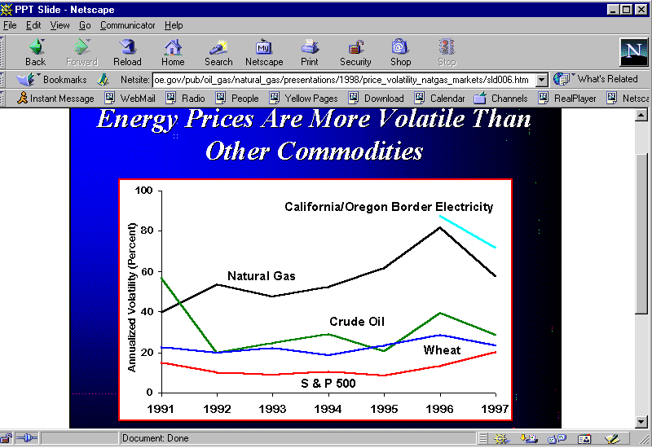

Volatility came to the natural gas industry with deregulation of wholesale prices in 1984 and is now a regular feature of the industry:

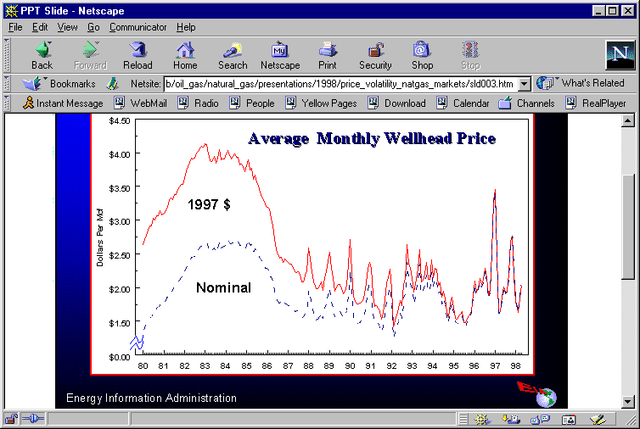

The experience of Berkshire Gas Co. – as good a purchaser as any in the Commonwealth -- is typical: spot prices, the most volatile of commodity gas prices, ranged between $1.67 and $9.75 per Dth in the period September 1998 to January 2001 – a jump of almost six times. The balance of Berkshire gas purchases are for peaking and storage. Even rolling in peaking and storage prices, the Company’s cost of purchased gas rides a roller coaster that doubles its price at some months compared to others.

In the winter of 2000-2001, spot gas prices reached the highest point on record ($10.53 per MMBtu) and did so during an unusually cold winter.

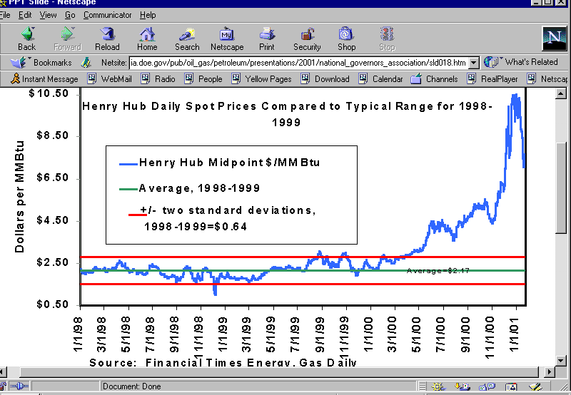

But this was no one-time event. Prices have approached this level in the recent past, for example, surpassing $8.00 in February 1996.

To understand how unpredictable these price movements are, one need only compare year-ago forecasts with current actual prices. The Energy Information Administration forecast of a year ago predicted spot prices this month (January 2002) of more than $5.00:

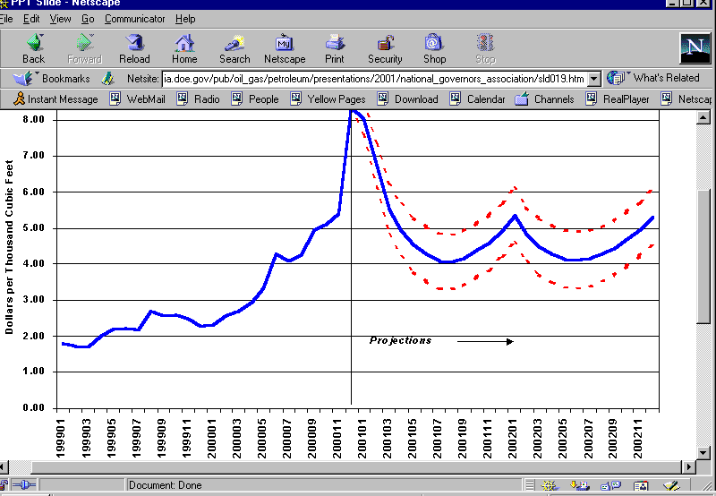

US EIA -- Natural Gas Spot Prices: Base Case and 95% Confidence Interval (dotted)
Sources: History – Natural Gas Week; Projections – Short-Term Energy Outlook, Jan. 2001

The current reality is more than 35 percent less: $3.245:

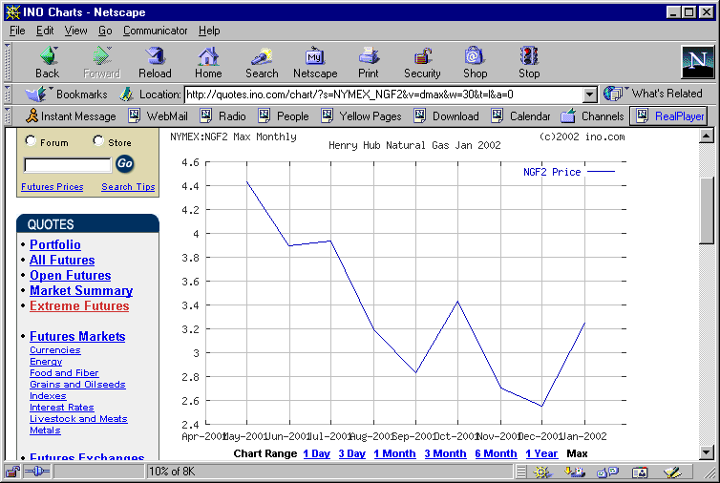

Similarly, the professional traders who in May 2001 predicted that May 2002 gas would be priced at about $3.80 now predict about 40 percent less, $2.315:

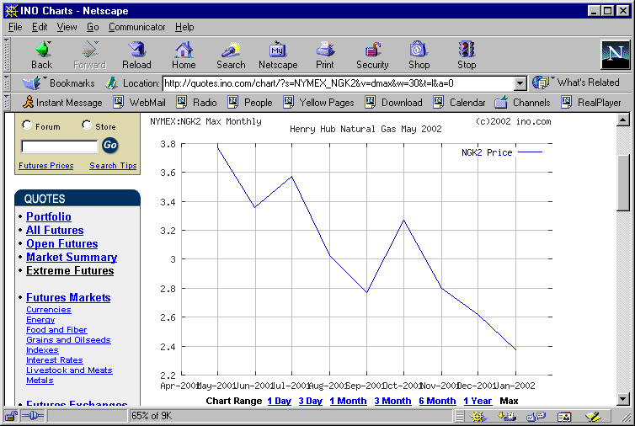

At other times, the situation is reversed and forward purchase prices turn out to be below spot.

These are not price swings that residential customers, particularly low-income customers, can budget for. Low-income families already devote about four times as much of their small incomes to energy as do other households. The tens of thousands of families who are already struggling to both meet their gas heat bills and have enough left over for food and rent simply cannot cope with such highly unpredictable gas bills. Even averaging an entire winter’s commodity price swings, and taking into account stable distribution rates, a heating bill increase of 50 percent raises a typically difficult low-income burden of devoting about 15 percent of income to energy to an almost impossible task of setting aside 22 percent of income. For the thousands of families with even greater burdens, last winter was nothing short of desperate.

For low-income customers, skyrocketing heating bills arrive in the context of incomes that have declined despite the historic economic expansion that just ended. While the economy boomed for the richest fifth of Massachusetts families, whose incomes rose 18 percent from the late 1980s to the late 1990s, incomes of 60 percent of Massachusetts families actually dropped. For the poorest fifth, the drop was eight percent; the next-to-poorest lost nine percent of their incomes; and the middle fifth lost four percent:

Now, rising unemployment and recession affects the lowest-income families first and worst. The result has been rising unpaid bills and the specter this winter of families unable to pay the bills to heat their homes.

The combined effects of unemployment, recession, and last winter’s skyrocketing heating bills is clearly reflected in residential arrears. For example, at Berkshire Gas, arrears are more than double their level of a year ago. Most alarmingly, unpaid bills that are more than four months old are 144 percent greater than a year ago.

There is no public interest that is served by policies that lead to heatless homes, unpaid utility bills, and additional suffering heaped on those already most disadvantaged.

- Under current policies, there is a disincentive for Massachusetts gas utilities to reduce price volatility.

Under current policies, Massachusetts gas utilities are allowed to simply pass through commodity gas that is purchased at current spot prices. Were a utility to take steps to reduce price volatility, e.g., by forward purchases at set prices, all would be well if forward-purchased gas prices turned out to be equal to or less than actual spot prices. If the situation were reversed, however, as in the past 12 months, the utility would bear a risk of disallowance for imprudent purchasing.

So the utility currently has this choice: (a) buy at volatile spot prices with no risk, or (b) take extra care to attempt to reduce price volatility and bear the risks of disallowance if the attempt does not work out in a particular instance.

As Bay State Gas Co. Vice President Stephen Bryant recently concluded: “Bay State would be exposed to greater prudence risks if a particular strategy did not materialize as expected, while customers would reap all the benefits if expectations were achieved.” Given this alignment of disincentives with respect to an activity for which utilities can earn no profit, despite gas utilities’ obligation to provide just and reasonable rates, it is not surprising that Massachusetts utilities currently do little to lower price volatility.

In the view of LEAN et al., the Department should remove the disincentive for Massachusetts gas utilities to lower price volatility for their customers. The simplest way to do this is to control the utilities’ perceived risk of imprudence review.

- Pre-approval of a limited menu of conservative purchasing practices could lower price volatility for customers without increasing risk for utilities.

In order to control price volatility, the Department should require Massachusetts gas utilities to purchase their commodity gas on a hedged or laddered basis. Instead of buying 100 percent of non-storage, non-peaking gas on the spot market, utilities should be required to purchase a portfolio of diverse resources using one or more conservative spricing strategies. For example, buying some supplies for future delivery at prices fixed at the time of contract can help stabilize the Company’s cost of purchased gas. The overall strategy should be set in advance by the Department to minimize utility risk.

Thus the principle of dollar-cost-averaging would be employed to stabilize gas prices just as it is used to dampen purchase cost volatility in securities portfolios. Gas can be purchased at fixed prices for many years in the future, so a series of purchases can be made for one year away, two years, and so on out to ten or 20 years. Each year a new series of contracts would replace expiring ones. In this way, the volatility of many years of pricing would be averaged into a price that would be relatively stable. One could never guarantee that this would be the “lowest” price, but it would be impossible for such averaged prices to double, triple or worse in any one year.

In this way, low-income and other residential customers would receive the benefits of hedging strategies already well-known to large customers. While residential customers are now served entirely at spot market prices, “[l]arge-volume gas customers typically have a portfolio of supply contracts and do not rely solely on spot purchases so their total average price tends to vary less than spot prices.”

Massachusetts has fallen behind in protecting its residential gas heating customers from the calamity of doubled prices. Many states require utilities to manage their portfolios in a manner that reduces price and price volatility, such as by hedging and long-term contracts. For example, New York State Electricity & Gas Co. (NYSEG) hedged more than 90 per cent of its expected electricity demands for the summers of 2001 and 2002. Similarly, Niagara Mohawk Power Corp. has proposed a ten-year rate plan under which residential electricity rates will be 95 perscent (declining to 90, then 85, per cent) hedged. New York State regulatory policy requires gas utilities to take such actions:

Local [gas] distribution companies have many ways to meet their loads; they should consider all available options … [which] may include short and longer term fixed price purchases, spot acquisitions, the use of financial hedges … While we are not directing any particular mix of portfolio options, volatility of customer bills is one of the criteria, along with other factors such as cost and reliability, that LDCs should consider … Any utility without a diversified pricing strategy will have to meet a heavy burden to demonstrate that its approach is reasonable.

In Maine, the state took over the function of electricity generation procurement, insisting on multi-year bids in order to achieve price stability. After receiving no suitable bids, the state has currently locked in three-year prices for its three largest investor-owned electricity utilities. In the case of the largest utility, Central Maine Power, the rate is lower than before restructuring despite New England wholesale price volatility.

Similar actions to stabilize prices have been ordered or authorized in, for example, Arkansas, Colorado, Georgia, Idaho, Iowa, Kentucky, Michigan, Oklahoma, Virginia, California, Kansas, Mississippi and Missouri.

For these reasons, the Low-Income Energy Affordability Network, et al. urge the Department to require Massachusetts gas utilities to modify their purchased gas acquisition practices to minimize price volatility, including by minimizing purchases at spot prices. This should be done in a way that minimizes risk to both the Company and its customers. Thus the Department’s guidance should include the following elements:
- purchasing procedures shall be adjusted to include consumer price stability as a prime objective,
- purchasing procedures may therefore include forward contracts and hedging, with appropriate oversight and advance guidelines,
- the Company shall be financially protected from procedures pre-approved and prudently executed but that may, with hindsight, be seen as not least-cost, and
- the reasonable and prudent cost of procedures adopted to provide consumer price stability should be borne by those customers who benefit from them.

The result will be both more stable prices for consumers and decreased arrearages for utilities.

- Responses to the Department’s questions.

  - Allow vs. require

As explained above, residential rates must be stable to be just and reasonable. Therefore a price volatility mitigation program should be required of each gas utility.

  - Impact on competition

Competitors will be free to offer more risky and more complex offerings to those who desire them. There is a predictable, long-term residential load that will want to keep stable, “vanilla” rates. Requiring such customers to confront only volatile prices is neither just nor reasonable. At the moment, such volatility is the only option because there are no competitors offering residential gas service of any kind, hedged or not.

  - Limits on instruments

As described above, there is no need for instruments more complicated than a laddered series of long-term physical purchases. The demonstrations of price volatility above reveal that the risks are very high of any attempts to predict future prices. Basing retail gas prices on such predictions would increase the risks to consumers and should be rejected.

  - Volumes

(No response at this time.)

  - Core objective

Residential consumers require rates that are as low as possible, consistent with the economic health of the utility and price stability. A balance should be struck among these goals rather than choosing one to the exclusion of another. Current policy excludes price stability as an objective.

  - Assessment

As described above, strategies should be pre-approved to minimize after-sthe-fact review, which should be limited to prudent execution of approved strategies. In addition, the overall hedging policy should be reviewed by comparing actual prices with what prices would have been if spot prices had been passed through. This review, however, should cover a long enough period of years for results to be meaningful.

  - Standard of review

(See response to 6, above.)

  - Cost recovery

Utilities should be allowed recovery of all necessary and prudent costs of their provision of high quality service at just and reasonable rates. This should include the ordinary costs of price volatility mitigation.

  - Incentives

Gas utilities are obliged by statute to provide high quality service at just and reasonable rates. The current disincentives to do so should be removed. There is no evidence that any incentive beyond a regulated (and thus protected) rate of return should be provided as an inducement to comply with the statutory requirement of just and reasonable rates.

- Conclusion.

For the reasons given above, LEAN et al. urge the Department to adopt price volatility mitigation requirements that include these provisions:
- purchasing procedures shall be adjusted to include consumer price stability as a prime objective,
- purchasing procedures may therefore include forward contracts and hedging, with appropriate oversight and advance guidelines,
- the Company shall be financially protected from procedures pre-approved and prudently executed but that may, with hindsight, be seen as not least-cost, and
- the reasonable and prudent cost of procedures adopted to provide consumer price stability should be borne by those customers who benefit from them.

In order to further develop this policy, there should be additional input from all stakeholders. This might be best accomplished by a round of reply comments to more fully determine where there is agreement among stakeholders and where there are points of view that need to be reconciled. Such a round of comments could be productively followed by a round of proceedings designed to elicit broad agreement. If such discussions failed to reach substantial agreement, the Department should hold formal hearings to allow each point of view to be fully presented.

Respectfully submitted,

Low-Income Energy Affordability Network (LEAN),
the weatherization and fuel assistance program network, and
Massachusetts Community Action Program Directors Association Inc
by their attorneys,

Jerrold Oppenheim, Esq.
57 Middle St.
Gloucester, Mass. 01930
978-283-0897
Fax 978-283-0957
JerroldOpp@tgic.net

Charles Harak, Esq.
National Consumer Law Center
77 Summer St.
Boston, Mass. 02110
617-523-8010
Fax 617-523-73998
charak@nclc.org

Dated: January 14, 2002

Joan Heinkel and William Trapmann, “Price Volatility in Natural Gas Markets” at slides 5, 6 (at DOE/NARUC Conference, Oct. 5, 1998).
Id. at slide 3.
Exh. LEAN 1-3 in Berkshire Gas Co. rate case, D.T.E. 01-56.
Even stored gas prices have varied by a factor of more than 2. Exh. LEAN 1-4 in D.T.E. 01-56.
Exh. LEAN 1-1E in D.T.E. 01-56.
John Cook (Director, Petroleum Div., U.S. Energy Information Administration), “Presentation for National Governors’ Association” at slide 18 (Jan. 26, 2001).
John Herbert, James Thompson, James Todaro, “Recent Trends in Natural Gas Spot Prices,” Natural Gas Monthly (U.S. E.I.A., Dec. 1997).
John Cook (Director, Petroleum Div., U.S. Energy Information Administration), “Presentation for National Governors’ Association” at slide 19 (Jan. 26, 2001).
Info.com (Jan. 10, 2002).
Id.
Bernstein, McNichol, Mishel, and Zahradnik, Pulling Apart (Economic Policy Institute and Center on Budget and Policy Priorities, 2000).
LEAN-RR-2 in D.T.E. 01-56.
Pre-filed testimony in proposed Gas Cost Incentive Mechanism docket, D.T.E. 01-81.
Of course, utilities would be required to exercise the strategy prudently.
Where there are opportunities for exceptionally low prices, it may be wise to permit utilities to petition for permission to make additional purchases than would normally be contemplated.
This is not a proposal for a fixed price, or a fixed price option for customers to choose or not, which would be considerably more difficult administratively.
Joan Heinkel and William Trapmann, “Price Volatility in Natural Gas Markets” at slide 3 (at DOE/NARUC Conference, Oct. 5, 1998).
Form 8-K at 2 (Sept. 18, 2000).
Joint Proposal in NYPSC Case No. 01-M-0075 (October 11, 2001).
Statement of Policy Concerning Gas Purchasing Practices at 4-5, Case 97-G-0600 (April 28, 1998).
Personal communications, Consumer Advocate Stephen Ward (Oct. 29, 2001), consumer consultant Barbara Alexander (Oct. 30, 2001).
Arkansas Gas Utilities, 210 PUR4th 325 (Ark. PSC 2001).
Dec. No. C01-207 in Colo. PUC Docket No. OIR-0835 (March 27, 2001).
Savannah Electric Power Co., 210 PUR4th 335 (Ga. PSC 2001).
Intermountain Gas Co., Order No. 28783 in Case No. INT-G-01-3 (Ida. PUC, July 13, 2001), 210 PUR4th, No. 2 at iv.
Docket No. RMU-00-6 (Iowa Utils. Bd. June 21, 2000).
Western Kentucky Gas Co., 210 PUR4th 331 (Ky. PSC 2001).
Consumers Energy Co. (gas), 212 PUR4th 175 (Mich. PSC, 2001).
Oklahoma Natural Gas Co., 211 PUR4th 230 (Okla. Corp. Comm. 2001).
Washington Gas Light Co., 212PUR4th 375 (Va. St. Corp. Comm. 2001).
R. Linden, “Gas Price Prudence: From Hedge-and-Hope to Best Practice,” Public Utilities Fortnightly at 34 (Oct. 1, 2001).

